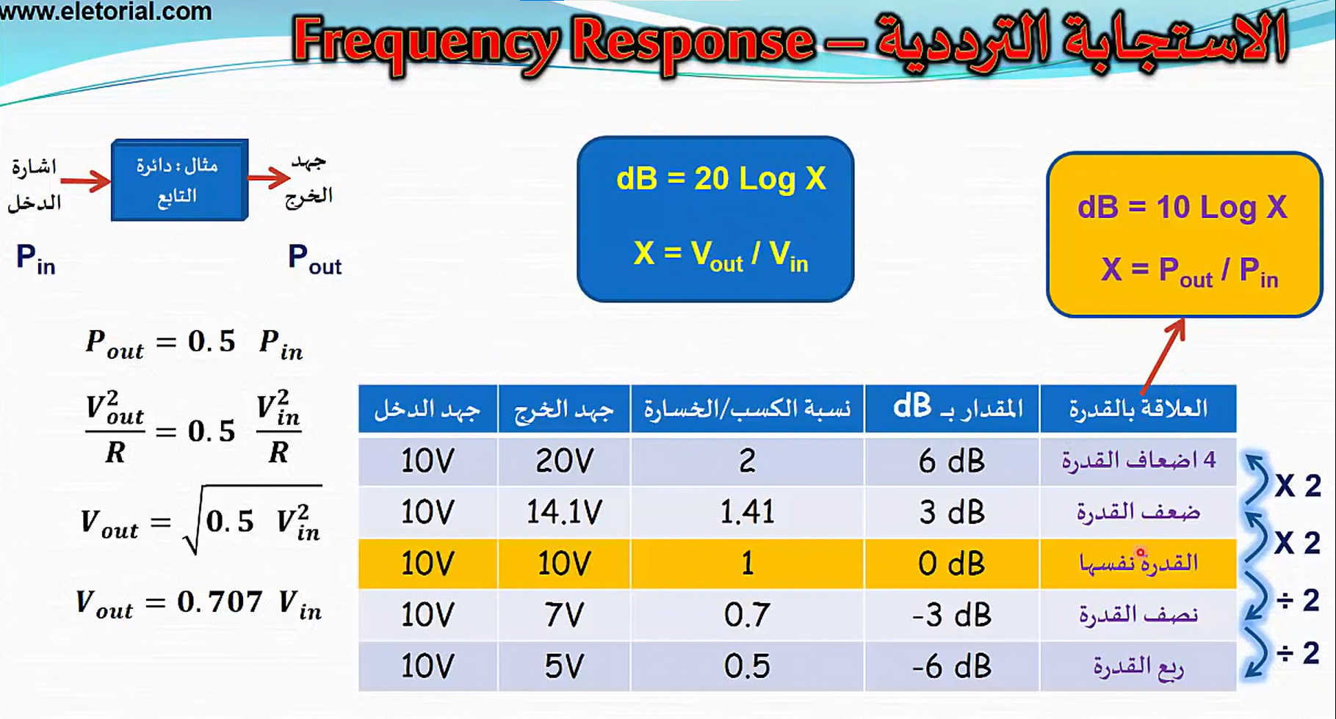



If different ICs then use the less BW